Machine Learning-Based Shoreline Change Prediction and Erosion Analysis: A Case Study of Ogu/Bolo, Nigeria
Ifunanya Osondu*¹, Okes Imoni^{2,} Prince Chukwuemeka³, Meremu Dogiye Amos⁴, David Inioluwa Ajibade⁵, Omabuwa O. Mene-Ejegi⁶, Chinwe Felicia Mogo⁷, Desmond R. Eteh ⁸, Endurance Onyenweuwa Nwadoziokwu⁹, Charles U. Akajiaku¹⁰
¹Department of Geology, University of Port Harcourt, Port Harcourt, Rivers State, Nigeria; Email: osonduifunanya77@gmail.com; ORCID: https://orcid.org/0009-0003-4521-3755
²Department of Biological Sciences, Niger Delta University, Wilberforce Island, Bayelsa State, Nigeria; Email: jennyimoni@gmail.com; ORCID: https://orcid.org/0009-0007-3548-2889
³Department of Computing and Informatics, Bournemouth University, Poole, United Kingdom; Email: pchukwuemeka424@gmail.com; ORCID: https://orcid.org/0009-0005-1850-9870
⁴Department of Petroleum Engineering, Rivers State University, Port Harcourt, Rivers State, Nigeria; Email: contactmeremutech@gmail.com
⁵Department of Computer Science, Federal University of Agriculture, Abeokuta, Ogun State, Nigeria; Email: ajidaveini@gmail.com; ORCID: https://orcid.org/0009-0004-5559-3891
⁶Department of Environmental Management and Control, Rivers State University, Port Harcourt, Rivers State, Nigeria; Email: Omabuwa.ejegi@outlook.com; ORCID: https://orcid.org/0009-0002-5262-3923
⁷African Marine Environment Sustainability Initiative (AFMESI), Suite 2, Silverwood Court, DPK District, Off Orchid Road, Lekki County, Lekki–Epe Expressway, Lagos, Nigeria; Email: felichimogo@yahoo.com
⁸Department of Geology, Niger Delta University, Wilberforce Island, Bayelsa State, Nigeria; Email: desmondeteh@gmail.com; ORCID: https://orcid.org/0000-0003-0660-6743
⁹Electronic/Electrical Engineering, University: University of Leeds, Leeds, England, United Kingdom
Email: endurancenwadoziokwu@gmail.com

¹⁰Department of Geology, University of Port Harcourt, Port Harcourt, Rivers State, Nigeria Email: akajiakuflowz@gmail.com

* Corresponding author: Ifunanya Osondu, Email address: osonduifunanya77@gmail.com

Highlights
- Extensive shoreline retreat: Over 78% of transects showed erosion between 1984 and 2024, averaging –1.49 m/year.
- Machine learning enhances prediction: Random Forest outperformed SVM and LSTM in predicting shoreline change with R² = 0.88.
- Key erosion drivers identified: Mangrove loss (–17 km²), low elevation, and flat slopes were major contributors.
- Future risks mapped: Projected shoreline changes to 2044 indicate retreat up to 20 meters in erosion hotspots.
- Integrated framework proposed: Combines DSAS, geospatial analysis, and explainable AI for coastal risk assessment and management.
Abstract
This study examines shoreline change and erosion dynamics along the Ogu/Bolo coastline in Nigeria’s Niger Delta from 1984 to 2024, with predictive projections to 2044. The objective was to quantify past shoreline shifts, identify key environmental and anthropogenic drivers, and develop accurate predictive models for future shoreline positions. Multi-temporal Landsat imagery, combined with datasets on topography, land use/land cover, slope, elevation, and vegetation indices, was processed using the Digital Shoreline Analysis System (DSAS) across 94 transects. Shoreline displacement was evaluated using End Point Rate (EPR) and Weighted Linear Regression (WLR), while predictive modeling employed Support Vector Machine (SVM), Random Forest (RF), and Long Short-Term Memory (LSTM). SHapley Additive exPlanations (SHAP) analysis was applied to identify the most influential predictors, including distance to tidal inlets, Normalized Difference Vegetation Index (NDVI), and slope. Results showed that 78.72% of transects experienced net erosion, with a mean retreat of –1.49 m/year. RF achieved the highest prediction accuracy (R² = 0.88; RMSE = 0.92 m). Morphological analysis indicated a cumulative land loss of 0.89 km², while land use assessments linked erosion hotspots to mangrove deforestation (–17 km²), low elevations (<2 m), and flat slopes (<1°), exacerbated by sand mining and dredging. Projections suggest erosion hotspots may retreat by over 20 m in some areas by 2044. The study demonstrates the value of integrating remote sensing, statistical analysis, and explainable artificial intelligence (AI) for shoreline prediction, providing actionable insights for coastal management, ecosystem restoration, and policy intervention.
Keywords:
Coastal Erosion, Landsat Imagery, LULC change, Machine Learning, Remote Sensing, Shoreline Change

1. Introduction
Coastal zones are globally recognized as some of the most dynamic and ecologically sensitive environments, functioning as transitional interfaces between land and ocean while supporting over 40% of the world’s population [1–4]. These regions host rich biodiversity, critical cultural assets, and numerous economic activities, yet they are increasingly threatened by natural and anthropogenic pressures [5,6]. Coastal erosion has emerged as a significant hazard worldwide, contributing to habitat degradation, infrastructure loss, and socio-economic instability [7,8]. Climate projections from the Intergovernmental Panel on Climate Change (IPCC) indicate that global sea levels may rise by 0.26–0.77 m by the year 2100, thereby intensifying erosion risks in vulnerable coastal areas [9]. Recent global assessments reveal that more than 24% of sandy shorelines are retreating at rates exceeding 0.5 m/year [6], with accelerated erosion observed in South/Southeast Asia, West Africa, and parts of Europe due to sediment starvation, river damming, unregulated coastal development, and climate-induced sea-level rise [10,3,4]. These risks are further exacerbated in developing nations where adaptive capacity is limited and exposure to hazards is high [11–13].
The Niger Delta region of Nigeria typifies these vulnerabilities, with its low-lying terrain, extensive mangrove forests, and dynamic sedimentary systems making it highly susceptible to shoreline retreat [14–16]. Decades of hydrocarbon exploration, dredging, mangrove deforestation, and poorly regulated development have altered sediment dynamics and disrupted natural coastal processes, resulting in widespread and persistent erosion [17–19]. Traditional shoreline monitoring approaches—such as field surveys and aerial photography though valuable, are often costly, logistically demanding, and spatially constrained [20–22]. Advances in remote sensing (RS) and Geographic Information Systems (GIS) now allow for multi-temporal shoreline extraction at regional scales [23–25]. However, while tools like the Digital Shoreline Analysis System (DSAS) offer robust historical assessments [26,27], they lack the capacity to accurately forecast future shoreline positions needed for evidence-based planning [28]. Recent developments in machine learning (ML) present a promising alternative, enabling the modelling of nonlinear and multi-factor environmental systems using algorithms such as Support Vector Machines (SVM), Random Forest (RF), and Long Short-Term Memory (LSTM) networks [29–35]. Despite these advances, their application in coastal systems across West Africa remains limited due to sparse historical datasets, poor monitoring infrastructure, and methodological gaps [33].
Addressing these challenges is particularly important in Nigeria’s Niger Delta, where the impacts of rising seas, land subsidence, sediment deficits, and ecosystem degradation pose severe environmental and socio-economic risks. This study therefore integrates multi-temporal RS–GIS datasets with machine learning to quantify historical shoreline change, identify key environmental and anthropogenic drivers, and develop a predictive framework for future shoreline displacement in Ogu/Bolo, Niger Delta. The novelty of the study lies in its hybrid methodological framework, which (i) combines DSAS-derived metrics with ML-based predictive modelling; (ii) incorporates ecological indicators such as mangrove extent, NDVI, elevation, and slope; and (iii) applies explainable ML tools to identify the most influential drivers. This integrated workflow provides a scalable and transferable model suitable for data-scarce tropical deltas and other geological terranes facing similar erosion pressures. The study’s specific objectives are to: (1) quantify multi-decadal shoreline changes (1984–2024) using DSAS; (2) develop and validate ML models (SVM, RF, LSTM) to predict shoreline positions up to 2044; and (3) identify and evaluate the environmental and human factors influencing shoreline dynamics. The outcomes contribute to coastal geomorphology, hazard modelling, and climate resilience research by offering a science-driven, replicable approach for shoreline prediction and integrated coastal zone management (ICZM).

2 Study Area
Ogu/Bolo Local Government Area (LGA) is in Rivers State, Nigeria, and forms part of the ecologically and socio-economically significant Niger Delta region. The Niger Delta is among the world’s largest and most dynamic deltas, consisting of an intricate network of rivers, creeks, estuaries, and extensive mangrove forests [5,3]. Ogu/Bolo covers an estimated area of about 89 square kilometers, geographically situated between latitudes 4°33’N to 4°47’N and longitudes 6°50’E to 7°10’E (Figure 1). The area’s low-lying terrain, with elevations close to sea level, makes it highly vulnerable to tidal influences, storm surges, sea-level rise, and coastal erosion [36]. The climate is typically tropical, characterized by two main seasons: a rainy season lasting from March to October and a dry season from November to February. The region receives an average annual rainfall of approximately 2,500 to 3,000 millimeters, which drives extensive river discharge and sediment transport [37]. Temperatures generally range between 24°C and 32°C, while relative humidity often exceeds 80% throughout the year [7].
Ecologically, Ogu/Bolo hosts rich mangrove ecosystems that play crucial roles in shoreline stabilization, biodiversity support, and provision of livelihood resources for local communities [38,39]. However, these ecosystems face increasing threats from anthropogenic pressures such as urbanization, sand mining, and deforestation. The removal of mangrove vegetation has been shown to accelerate shoreline retreat, as the loss of root networks reduces natural protection against wave energy and sediment erosion [39]. Socio-economically, the inhabitants of Ogu/Bolo rely heavily on artisanal fishing, subsistence farming, and small-scale trading, while recent years have seen expansion into commerce, infrastructure development, and land reclamation [40.41]. Such unregulated expansion often encroaches upon vulnerable coastal areas, intensifying the impacts of erosion and exposing communities to greater risks. Historical accounts and localized studies indicate consistent shoreline retreat, in some cases amounting to several meters per year, resulting in displacement of households, loss of agricultural land, and damage to infrastructure such as schools, health centers, and transportation networks [6]. Geologically, the Niger Delta is composed largely of unconsolidated sediments sands, silts, and clays deposited by the Niger River and its distributaries. These materials are inherently erodible, making shorelines highly susceptible to hydrodynamic forces such as waves, tides, and currents [42]. Seasonal variability in sediment supply, compounded by upstream damming and land-use change, further influences erosion dynamics and shoreline instability [4]. Given its ecological fragility, socio-economic significance, and heightened vulnerability to environmental change, Ogu/Bolo represents a critical case study for advancing knowledge on coastal erosion in the Niger Delta. Employing machine learning techniques to predict shoreline changes in this context offers valuable insights for policymakers and planners seeking sustainable coastal zone management strategies.
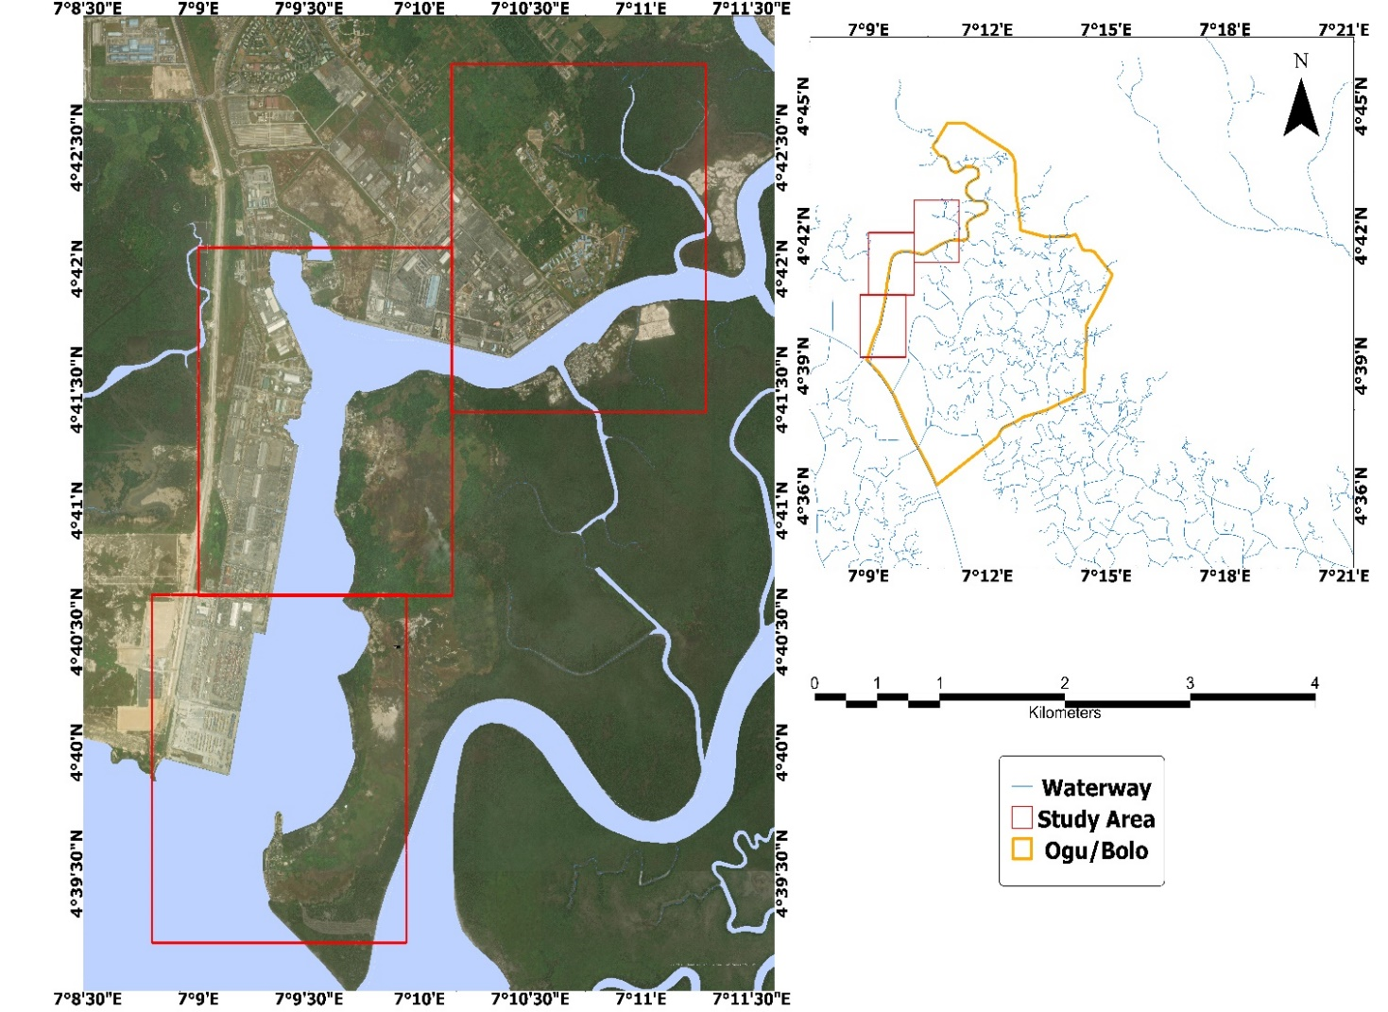
Figure 1: Location map of study area
3. Materials and Methods
3.1 Data Collection
To construct a high-resolution shoreline, change prediction model, we integrated multi-source datasets including satellite imagery, digital elevation models, in-situ shoreline GPS surveys, and environmental covariates [7, 4]. Table 1 summarizes the data sets used in this study.
Table 1: Landsat Satellite Data Sources and Acquisition Details
Satellite | Date Acquired | Path | Row | Spatial Resolution (m) | Data Sources
Landsat 1 | 24/12/1974 | 189 | 56 | 80 | USGS Landsat Archive – MSS Bands (4: Green, 5: Red, 6: Near-IR)
Landsat 4 | 21/12/1984 | 189 | 56 | 30 | USGS Landsat Archive – TM Bands (1–7)
Landsat 5 | 24/12/1994 | 189 | 56 | 30 | USGS Landsat Archive – TM Bands (1–7)
Landsat 7 | 30/12/2004 | 189 | 56 | 30 (15 panchromatic) | USGS Landsat Archive – ETM+ Bands (1–8)
Landsat 8 | 12/12/2014 | 189 | 56 | 30 (15 panchromatic) | USGS Landsat Collection 2 – OLI/TIRS Bands (1–11)
Landsat 8 | 17/02/2024 | 189 | 55 | 30 (15 panchromatic) | USGS Landsat Collection 2 – OLI/TIRS Bands (1–11)
The study leveraged the Landsat satellite series specifically, Landsat 4 (TM), Landsat 5 (TM), Landsat 7 (ETM+), and Landsat 8 (OLI/TIRS) spanning from 1984 to 2024 (Table 1) and Shuttle Radar Topographic Mission from U.S. Geological Survey (USGS), providing multispectral imagery with 30-meter spatial resolution, suitable for land–water discrimination in dynamic coastal environments [24,27]. Figure 2 illustrates the data acquisition and processing pipeline.
Images were acquired on cloud-free dates, and metadata-guided selection ensured radiometric consistency and temporal comparability. Spectral bands included visible, near-infrared (NIR), shortwave infrared (SWIR), and thermal infrared, facilitating spectral index derivation. Water detection relied on the Normalized Difference Water Index (NDWI) and Modified NDWI (MNDWI), which exploit contrast in water absorption characteristics in green, NIR, and SWIR bands [28]. These indices enhanced shoreline delineation accuracy by reducing confusion from urban shadowing and turbid water conditions:
To enhance water–land separation, spectral indices were applied:

SRTM DEM data were processed in ArcGIS to compute slope for terrain gradient assessment. Land use/land cover (LULC) was classified using Support Vector Machine (SVM) into classes such as water, vegetation, built-up area, bareland, and rangeland [34].
3.2 Preprocessing Workflow
All Landsat images were radiometrically calibrated to top-of-atmosphere (TOA) reflectance:

where is the calibrated pixel value, is the radiance multiplicative factor, and is the radiance additive factor.
Atmospheric correction used the Dark Object Subtraction (DOS1) method [21]. Cloud and shadow masking were conducted using the Fmask algorithm [23].
3.3 Field Data Acquisition
Ground-truth validation was performed using Differential Global Positioning System (DGPS) shoreline surveys conducted under low-tide conditions in the dry season to ensure spatial accuracy and alignment with satellite overpasses. Local knowledge was integrated through stakeholder interviews with coastal community residents, contributing qualitative insights into erosion history and socio-environmental Field-collected shoreline vectors were used to evaluate classification accuracy, quantified using the Root Mean Square Error (RMSE), with a threshold <10 m deemed acceptable for medium-resolution imagery [45].

where and are observed and predicted shoreline positions.

3.4 Shoreline Extraction and Change Analysis
Shoreline extraction utilized a hybrid method combining automated and manual procedures. NDWI and MNDWI raster outputs were thresholded (typically NDWI > 0.1) to segment water and land areas:

These binary images were vectorized to delineate shoreline boundaries [20,26]. Where spectral misclassification occurred, especially near estuaries manual vector editing and supervised classification using Maximum Likelihood Classifier (MLC) were applied [46].
To assess shoreline dynamics, the Digital Shoreline Analysis System (DSAS) in ArcGIS 10.8 was employed to compute change metrics. The End Point Rate (EPR) was calculated as:

The Linear Regression Rate (LRR) measured shoreline change trends over time, while the Weighted Linear Regression (WLR) accounted for positional uncertainty:

Change polygons were derived by overlaying historical shoreline vectors, identifying net erosion and accretion areas. These were quantified into categorical variables (e.g., -1 for erosion, +1 for accretion) and incorporated as target labels in machine learning (ML) models [47,48,49].
3.5 Machine Learning Modeling
A hybrid ML modeling framework was developed using Support Vector Regression (SVR), Random Forest (RF), and Long Short-Term Memory (LSTM) neural networks. Each algorithm was chosen for its specific strength in modeling non-linear relationships, feature interactions, or temporal dependencies in environmental data [34,45,50] The final dataset included predictors such as distance to shoreline (target), LULC class (one-hot encoded), normalized sediment load, night-time light intensity, monthly tidal range, and meteorological indicators.
Temporal sequences were structured using sliding windows with 3-year time steps for LSTM input [35]. SVR used a radial basis function (RBF) kernel with penalty parameter C=100 and . RF models used 500 trees with a maximum depth of 10. The LSTM model architecture comprised an input layer, 64 hidden units, dropout (0.2), and a dense output layer with Mean Squared Error (MSE) as the loss function:

Models were implemented in Python (TensorFlow and Scikit-learn libraries).
3.6 Model Training and Validation
The dataset was randomly partitioned into 70% training, 15% validation, and 15% testing subsets. To minimize the effect of spatial autocorrelation, a hybrid cross-validation scheme was adopted, combining both random and spatial clustering approaches [51,52].
Model accuracy was evaluated using multiple statistical metrics, including Root Mean Square Error (RMSE), Mean Absolute Error (MAE), Coefficient of Determination (R²), and Mean Bias Error (MBE). These metrics are defined as follows:

Predicted shoreline positions for 2044 were generated by extending LSTM model forecasts using historical trends. These were spatially validated against 2024 baselines in ArcGIS, highlighting future erosion and accretion hotspots to guide coastal management
Cross-Validation
10-fold cross-validation ensured generalizability, with each fold maintaining spatial coherence to prevent overfitting.

Residual Plots and Bootstrapping
Residuals were plotted against predicted shoreline positions. Bootstrapping (1000 iterations) provided error bounds:

Comparative Model Evaluation
LSTM outperformed other models due to its ability to model long-term dependencies.

GIS-Based Spatial Validation
Predicted shoreline layers for 2044 were overlaid on 2024 base maps in ArcGIS. The spatial accuracy matched model performance metrics and identified erosion hotspots, aiding coastal policy formulation.

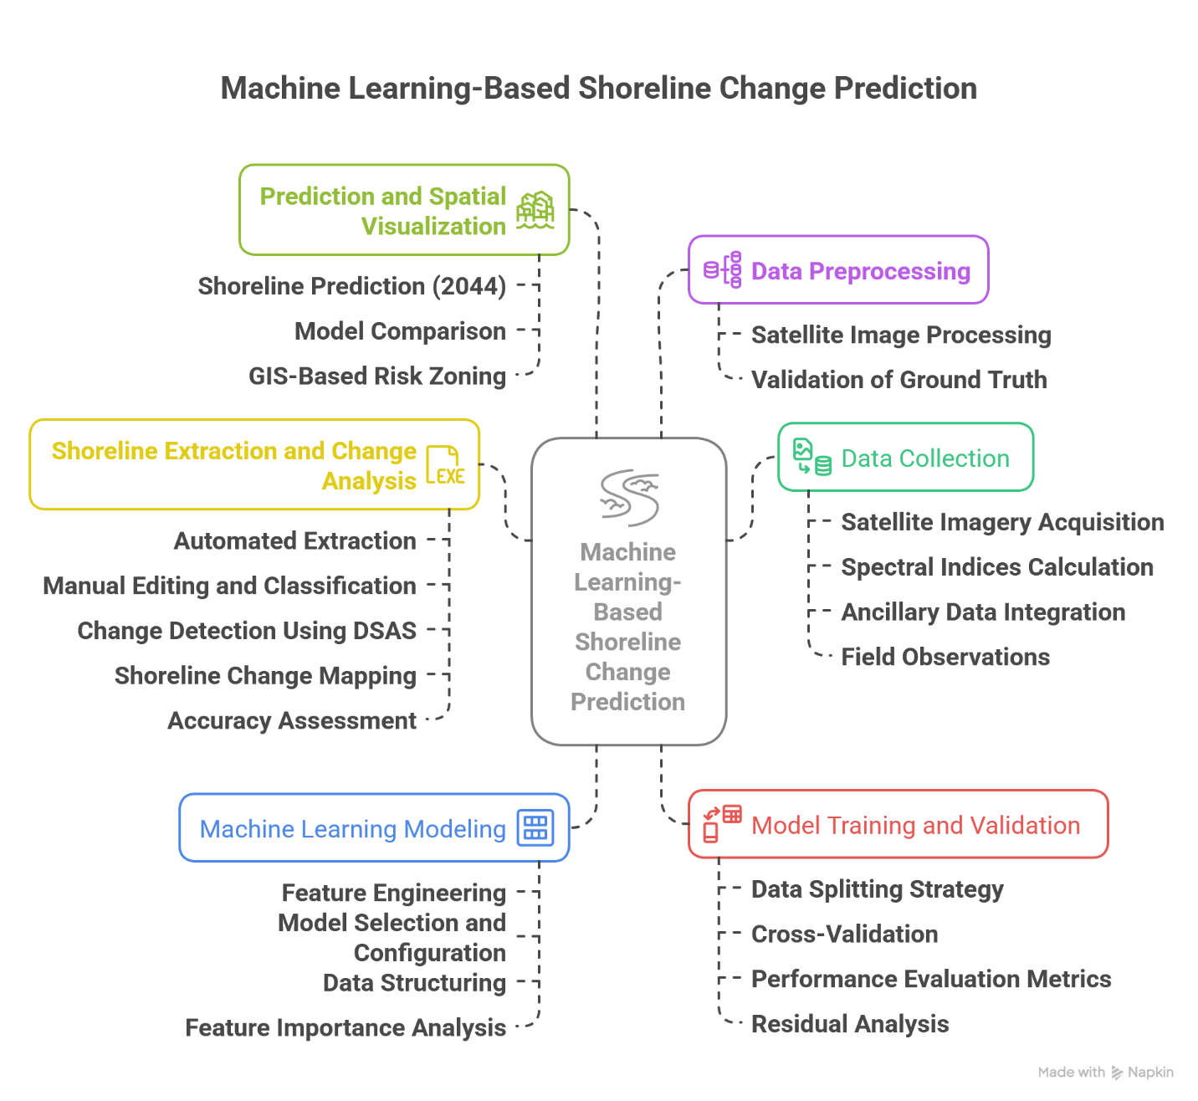

Figure 2: Workflow diagram
4. Results and Discussion

4.1 Results
4.1.1 Historical Shoreline Changes
Shoreline change analysis along the Ogu/Bolo coastline from 1984 to 2024 was performed using the Digital Shoreline Analysis System (DSAS) on multi-decadal Landsat imagery. The coastline was divided into 94 uniformly spaced transects to quantify shoreline displacement and long-term dynamics (Figure 3).
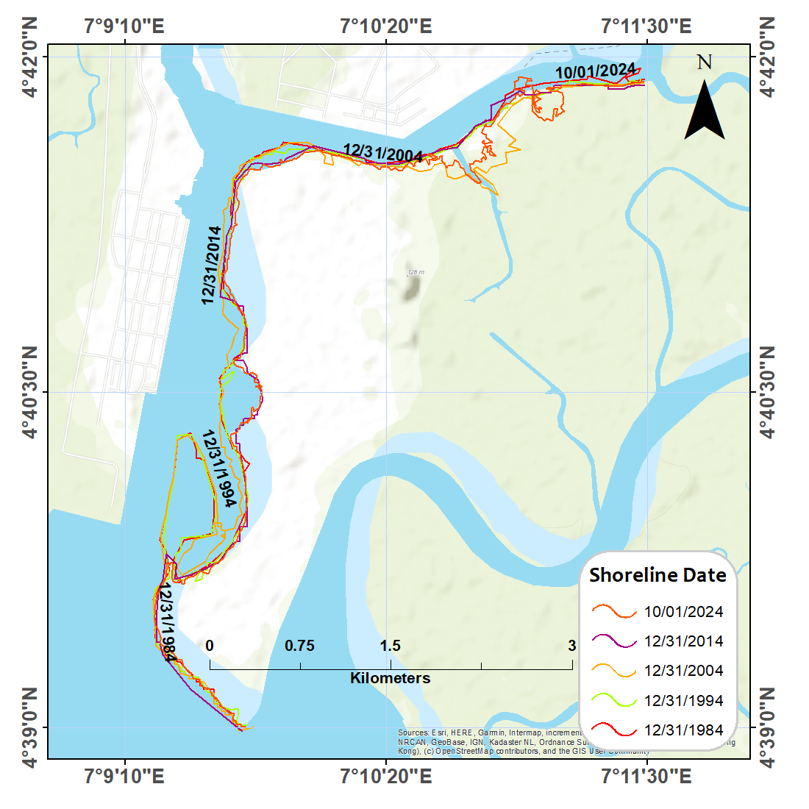
Figure 3: Shoreline Position 1984–2024

Table 2: Historical and Projected Shoreline Change Statistics (1984–2024 and 1984–2044)
Statistics | 1984-2024 | 1984-2044
Total transects | 94 | 94
Total erosion transects | 74 | 72
Total accretion transects | 18 | 17
Total stable transects | 0 | 0
Total erosion transects % | 78.72 | 76.6
Total accretion transects % | 19.15 | 18.09
Total stable transects % | 0 | 0
Mean shoreline change | -1.49 | -1.42
Mini shoreline change | -10.35 | -10.35
Maxi shoreline change | 1.8 | 1.96
Mean erosion | -1.62 | -1.51
SD erosion | 2.36 | 2.31
Mean accretion | 0.14 | 0.16
SD accretion | 0.38 | 0.42
Mean Shoreline Change Envelope (SCE) (m) | 136.7 | 128.92
Mean Net Shoreline Movement (NSM) (m) | -69.08 | -55.51
Mean End Point (EPR) (mm/yr) | -1.74 | -1.21
Mean Linear Regression Rate (LRR) (mm/yr) | -1.49 | -1.42
Mean Weighted Linear Regression (WLR) (mm/yr) | -1.49 | -1.42

The analysis revealed that erosion was the dominant process during the 40-year period. Out of 94 transects, 74 (78.72%) experienced shoreline retreat, while 18 (19.15%) showed accretion, and none remained stable (Table 2). The mean shoreline retreat rate was –1.49 m/year, with erosion reaching up to –10.35 m/year and maximum accretion recorded at +1.80 m/year (Figure 4).
Erosion transects exhibited an average retreat of –1.62 m/year with a standard deviation of 2.36 m, suggesting considerable spatial variability. In contrast, accreting transects gained an average of 0.14 m/year with lower variability (SD = 0.38 m).
A forward projection to 2044 indicates slight improvement: erosion-affected transects decrease marginally to 76.60%, while accreting transects reduce to 18.09%. The average shoreline change rate improves slightly from –1.49 m/year to –1.42 m/year.

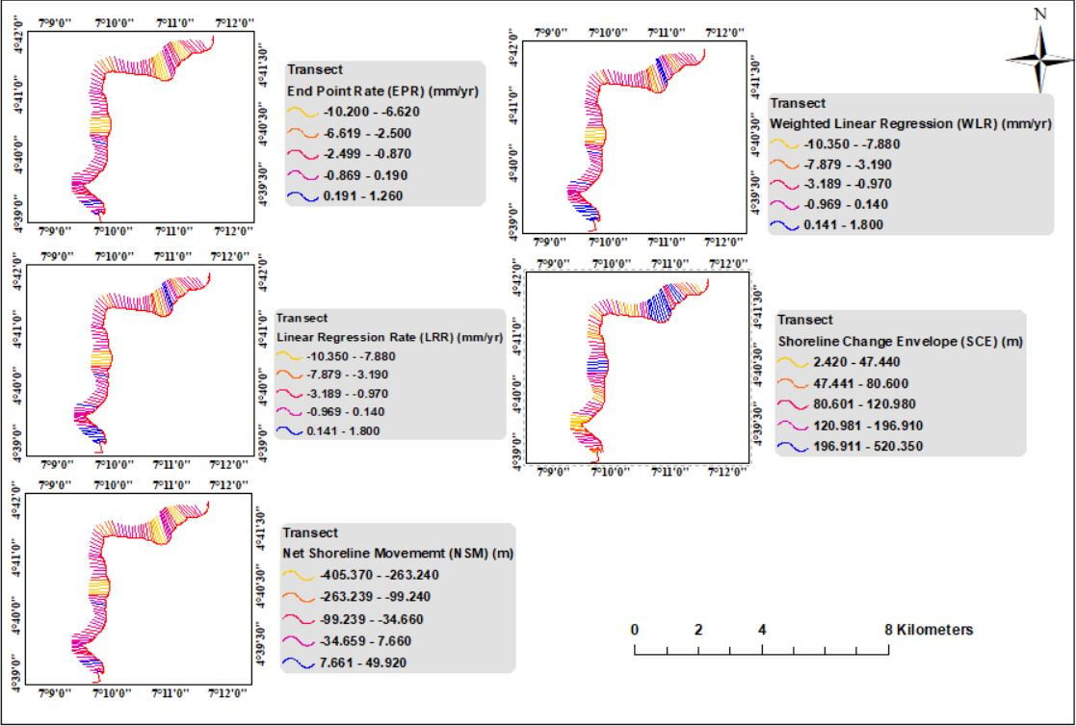
Figure 4: Shoreline Change Distribution along Transects (1984–2024)

4.1.2 Predictive Shoreline Changes
Future shoreline positions to 2044 were estimated using DSAS-based End Point Rate (EPR) and Weighted Linear Regression (WLR), supported by polynomial regression for error minimization.
The model projects that erosion will continue to dominate, though its intensity varies spatially. The number of erosion-impacted transects decreases slightly from 74 to 72 between 1984–2024 and 1984–2044 (Table 2). The mean shoreline retreat rate improves marginally from –1.49 m/year to –1.42 m/year. Spatial projections (Figure 5) show pronounced landward movement in central and eastern sectors. Areas of accretion are expected to diminish, while previously transitional zones are increasingly displaying signs of net erosion. Erosion hotspots are projected along creek mouths and estuarine inlets, with some areas potentially losing over 20 m by 2044.
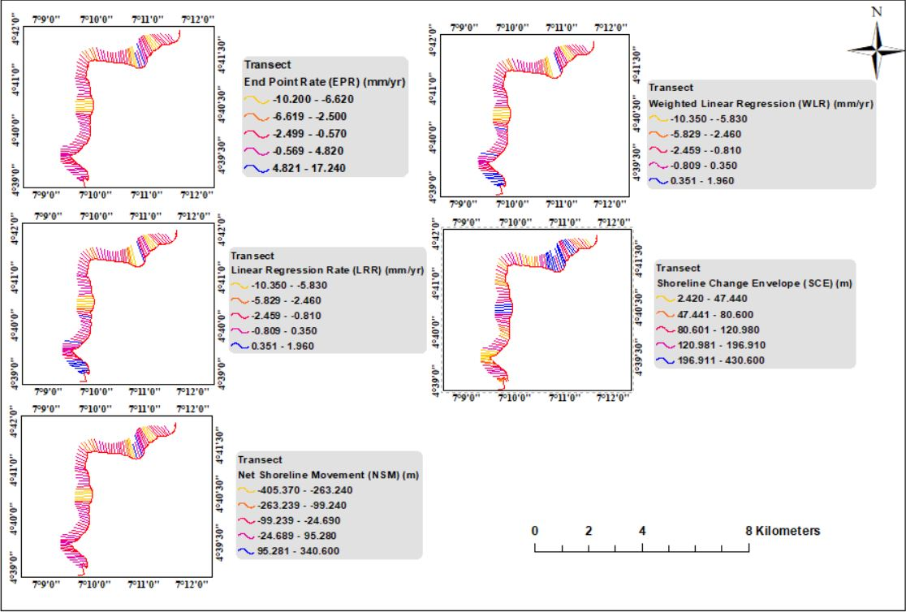
Figure 5: Predicted Shoreline Change Distribution along Transects 1984–2044
Notably, erosion-prone zones such as the southern margins near the creek mouths and estuarine inlets exhibit the greatest projected retreat, with some areas expected to lose over 20 meters of landmass by 2044. Conversely, minor accretion is anticipated in isolated locations, especially in western coastal stretches likely influenced by sediment deposition from tidal inflows. The projected shoreline positions raise significant concerns about settlement exposure, particularly in low-elevation, high-population zones near fishing settlements and infrastructural corridors. These findings align with prior studies predicting enhanced erosion under changing hydro-climatic regimes in the Niger Delta [53.54]. Although the model assumes temporal stationarity in forcing variables (e.g., sea-level rise, wave energy), it provides a critical early-warning insight into the spatiotemporal transformation of the Ogu/Bolo coast, forming the foundation for targeted shoreline protection and policy intervention. Figure 5 shows the model-projected shoreline for 2044, indicating similar hotspots of erosion in the eastern and central sectors of the study area. This agrees with the geospatial trajectory derived from historical observations and provides a decision-support tool for anticipatory planning.
4.1.3 Shoreline Position Change and Morphological Trends
The comparison of shoreline positions from 1984, 2004, and 2024 (Figure 6) provides a comprehensive view of long-term morphological changes along the Ogu/Bolo coast. The derived change polygons indicate that approximately 0.89 km² of land was lost through erosion, while accretion accounted for only 0.15 km², highlighting the disproportionate impact of erosional forces on the landscape. These polygons offer a spatially explicit representation of cumulative shoreline dynamics, setting a clearer baseline for assessing future risk.
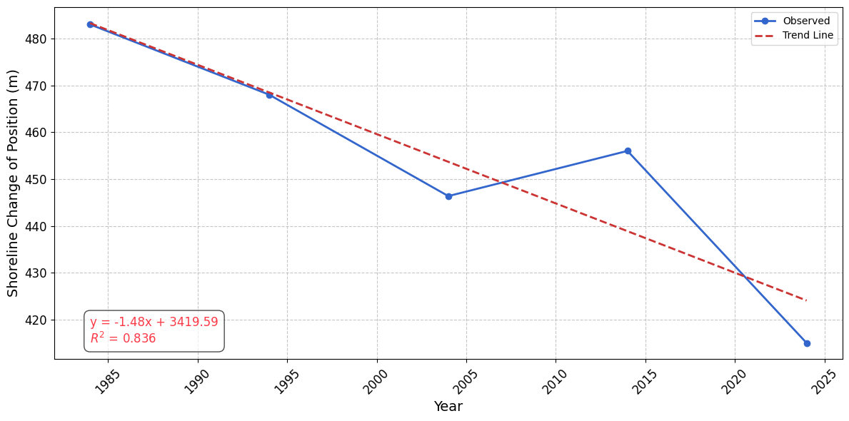
Figure 6: Shoreline Position Change and Trend (1985–2024).
The temporal evolution of shoreline positions shows a strong inverse relationship between shoreline distance and time, with a correlation coefficient (R²) of 0.834. This indicates that with each passing year, the coastline continues to migrate inland a trend that is both consistent and steadily increasing. The use of Weighted Linear Regression (WLR) further strengthens the reliability of this trend, as it accounts for positional uncertainties inherent in multi-temporal satellite datasets. These morphological patterns align with several studies that highlight the accelerating nature of shoreline retreat in deltaic environments due to tidal fluxes, sediment deficit, and human disturbances [55,56]. The combination of natural subsidence, rising sea levels, frequent inundation events, and anthropogenic pressures has disrupted sediment equilibrium, allowing erosional forces to dominate. As such, the Ogu/Bolo coastline exemplifies a classic case of geomorphic disequilibrium characteristic of many tropical deltas with high exposure to environmental and anthropogenic stressors.

4.1.4 End Point Rate (EPR) and Weighted Linear Regression (WLR)
Quantitative analysis of shoreline movement in Ogu/Bolo was conducted using two principal metrics: The End Point Rate (EPR) and Weighted Linear Regression (WLR). These statistical techniques, implemented through the DSAS tool, offer complementary perspectives on shoreline dynamics EPR measuring net change over time, and WLR providing a trendline through multiple observations with weight given to positional uncertainty Figures 7a–7d contains a detailed portrayal of shoreline change rates using EPR and WLR. The EPR results for 1984–2024 (Figure 7a and Table 2) show significant retreat values clustered between transects 35 to 70, while the WLR pattern (Figure 7c) confirms a near-identical spatial trend. In the predictive analysis (1984–2044), the EPR rates (Figure 7b) indicate some deceleration in retreat intensity, although key hotspots persist. Figure 7d (WLR 2044) also echoes this finding.
Statistically, EPR was found to have a mean of -1.74 mm/yr (historical) and -1.21 mm/yr (predicted), showing a positive shift. Similarly, WLR decreased slightly from -1.49 mm/yr to -1.42 mm/yr over the 60-year window (Table 2). These metrics are vital for understanding not only the spatial magnitude of changes but also their directional trend over time.
The value of WLR lies in its ability to account for measurement uncertainty and date variability by assigning weights to shoreline positions. In practice, this makes WLR a more robust indicator compared to EPR, which merely calculates the straight-line rate of change. This observation is supported by studies like Alesheikh et al. [57] and Dewi et al. [58], both of which emphasize the use of weighted regression in capturing complex shoreline behavior.
Notably, the model’s projection incorporates Weighted Linear Regression (WLR) and End Point Rate (EPR) as key inputs, which increase its reliability (Figure 7a–d). The average EPR dropped from -1.74 mm/yr in the historical period to -1.21 mm/yr in the scenario. Similarly, the WLR rate stabilized at -1.42 mm/yr. These trends suggest that although erosion persists, its intensity may reduce slightly in the coming decades, possibly due to changes in sediment input or sea level adjustments.
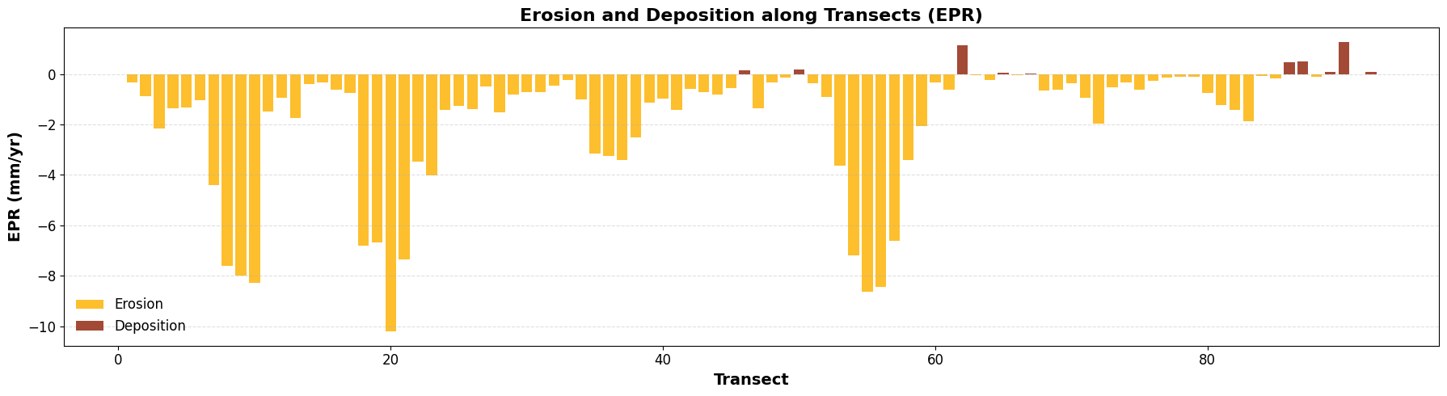
Figure 7a: EPR 1984-2024
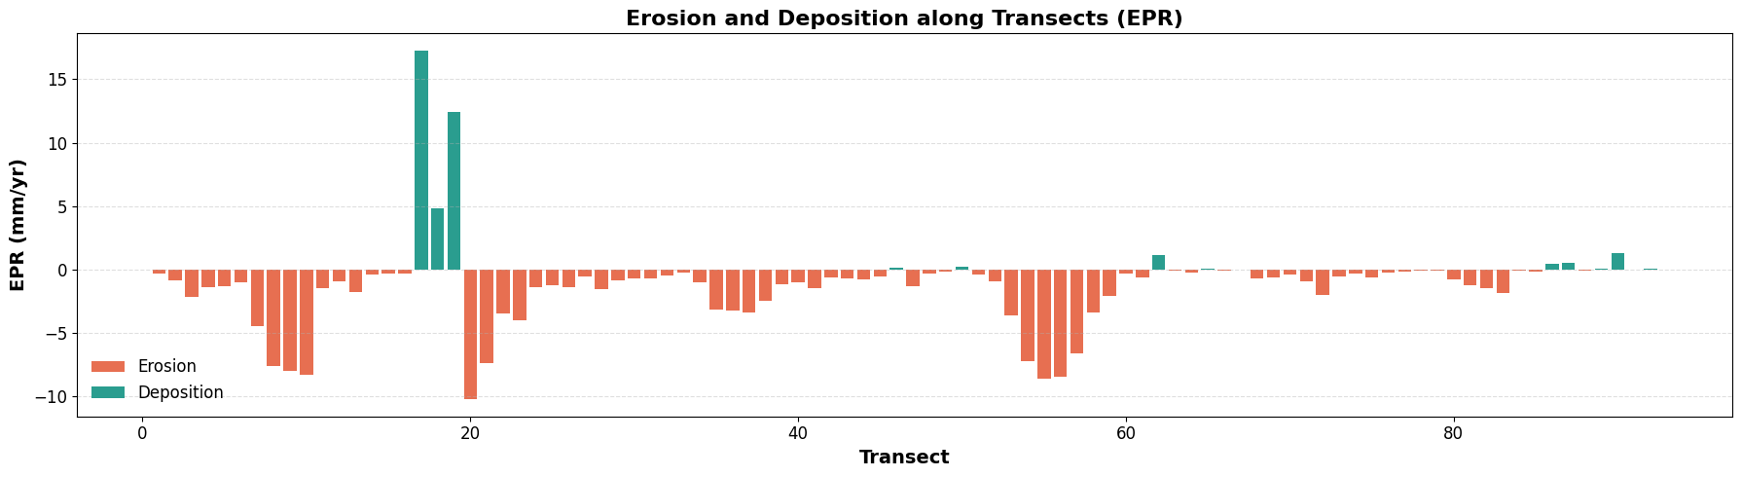
Figure 7b: EPR 1984-2044
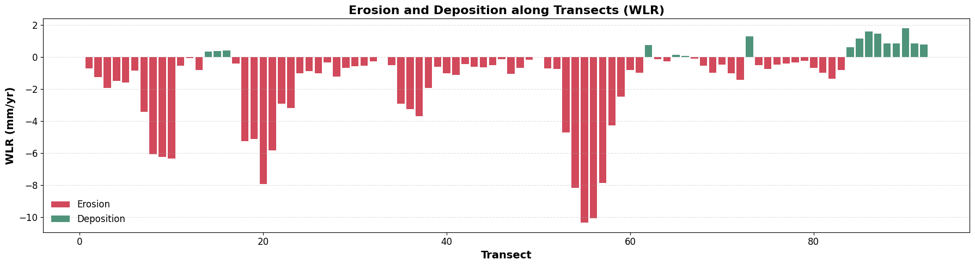
Figure 7c: WLR 1984-2024
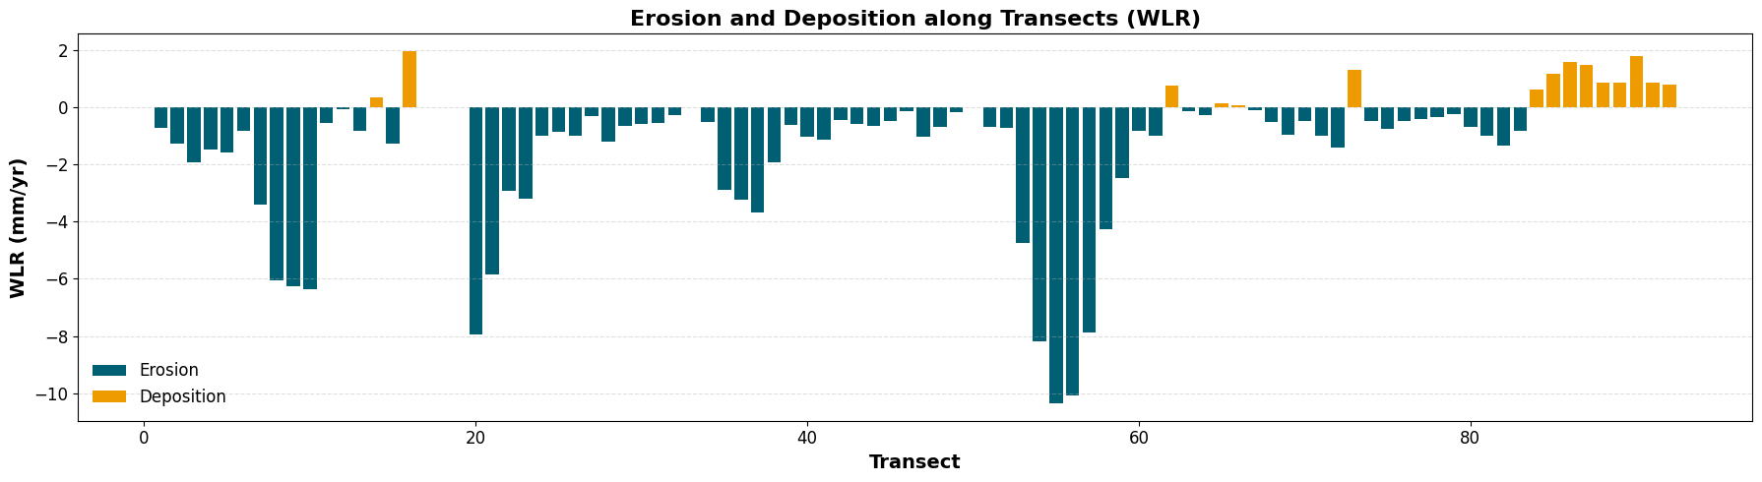
Figure 7d: WLR 1984-2044

The predictive model results are consistent with similar modeling efforts in other coastal systems. For example, Kaliraj et al. [59] applied machine learning-based modeling in Tamil Nadu, India, showing that future shoreline retreat was heavily influenced by past morphological patterns and human interference. Similarly, Natesan et al. [60] demonstrated the effectiveness of LRR and EPR in capturing shoreline evolution trends across low-lying coastal belts.

4.1.5 Erosion Rates
The spatial analysis of shoreline dynamics across the Ogu/Bolo coastline between 1984 and 2024, as derived from the Digital Shoreline Analysis System (DSAS), revealed a predominantly erosional regime marked by significant spatial heterogeneity in retreat intensity. Erosion rates were classified into three distinct categories based on their magnitude: high (> –5.00 m/year), moderate (–2.00 to –5.00 m/year), and low (< –2.00 m/year), following established coastal risk assessment frameworks [61.62].
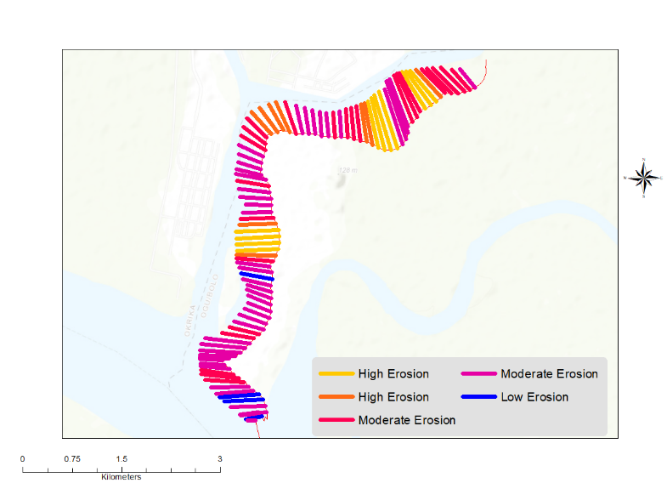
Figure 8: Spatial Classification of Erosion Rates along the Ogu/Bolo Coastline (2024–2024)
Figure 8 illustrates the spatial distribution of these erosion rates. Notably, the central and southeastern corridors of the coastline exhibited the most severe shoreline retreat, with rates exceeding –6.5 m/year. These areas are proximate to dynamic hydrological features such as estuarine mouths and distributary channels, where fluvial-tidal interactions and sediment transport discontinuities intensify coastal erosion. In contrast, moderate erosion was more prevalent along the western coastline, which benefits from partial sediment supply and reduced wave energy due to inland buffering. Zones experiencing low erosion or marginal accretion were mostly associated with stabilizing landforms, such as mangrove buffers and levees.
Table 3 provides a quantitative breakdown of transects according to erosion severity between 1984 and 2024. A total of 53 transects (56.38%) were classified under the high erosion category, while 21 transects (22.34%) fell within the moderate range. Only 18 transects (19.15%) exhibited low erosion or net accretion, and none were identified as stable. These figures mirror regional trends in the Niger Delta, where sediment deficits are driven by a complex interplay of natural subsidence, upstream dam regulation, channel dredging, and land reclamation activities [63,61].
Table 3. Categorization of Transects by Erosion Rate (1984–2024)
Erosion Category | Erosion Rate (m/year) | Number of Transects | Percentage (%)
High Erosion | > –5.00 | 53 | 56.38
Moderate Erosion | –2.00 to –5.00 | 21 | 22.34
Low Erosion / Accretion | < –2.00 to +1.80 | 18 | 19.15
Stable | 0.00 | 0 | 0.00
In projecting shoreline dynamics for the period 2024–2044, Table 4 and Figure 9 present the future categorization and spatial patterns of erosion rates. Although there is a marginal reduction in the extent of high-erosion zones dropping from 53 to 51 transects (–2.12%) the number of transects experiencing moderate erosion increased slightly, indicating a redistribution of erosion intensity rather than substantial stabilization. Emerging erosion hotspots, particularly along the central-western section, reveal the evolving and adaptive nature of shoreline retreat, emphasizing the critical need for sustained monitoring and localized mitigation strategies.
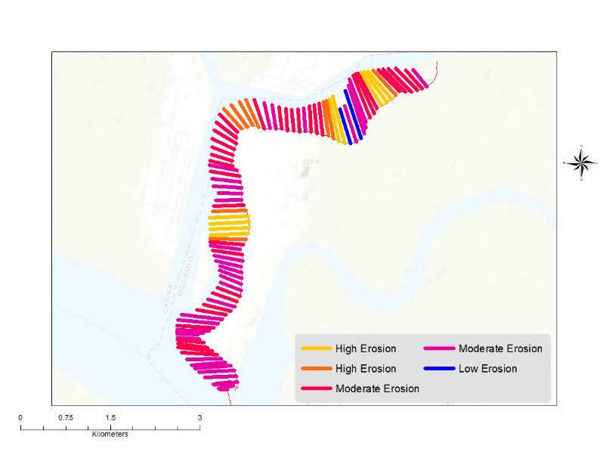
Figure 9: Spatial Classification of Erosion Rates along the Ogu/Bolo Coastline (2024–2044)
Table 4. Categorization of Transects by Erosion Rate (2024–2044)
Erosion Category | Erosion Rate (m/year) | Number of Transects | Percentage (%)
High Erosion | > –5.00 | 51 | 54.26
Moderate Erosion | –2.00 to –5.00 | 23 | 24.47
Low Erosion / Accretion | < –2.00 to +1.96 | 17 | 18.09
Stable | 0.00 | 0 | 0.00
These findings echo those of Abam [61], who noted that erosion hotspots in the Niger Delta often migrate laterally over time due to sediment redistribution and storm surges. Moreover, these areas are often poorly defended by natural vegetation or engineered structures, making them more susceptible to wave attack and land loss

4.1.6 Predictive Shoreline Changes Using Machine Learning
To enhance the predictive accuracy of shoreline dynamics along the Ogu/Bolo coastline, advanced machine learning (ML) techniques were employed to forecast future shoreline positions and classify erosion and accretion zones. This data-driven approach complemented traditional extrapolation methods such as End Point Rate (EPR) and Weighted Linear Regression (WLR), offering improved accuracy through the integration of spatial-temporal features derived from multi-year satellite-derived shoreline datasets and environmental covariates.
Three supervised learning algorithms Support Vector Machine (SVM), Random Forest (RF), and Long Short-Term Memory (LSTM) networks were implemented using transect-level data. Key predictive features included historical shoreline change rates, topographic slope, distance from tidal channels, NDVI values, and sediment types. The models were trained on 70% of the available shoreline data (1984–2014) and validated on the remaining 30% (2015–2024), ensuring model generalization and mitigating overfitting.
The box-and-whisker plots in Figure 10 illustrate the distribution of residual errors across the three models. The LSTM model achieved the lowest median residuals and narrowest interquartile range, indicating more consistent performance, although it exhibited a few high-leverage outliers. The RF model also performed strongly, showing moderate error spread with fewer extreme values, while the SVM model had the largest variance and several higher error values.
A Taylor diagram was constructed to further assess comparative model performance based on standard deviation, correlation, and centered RMS error (Figure 11). The RF and LSTM models were located closest to the reference point, indicating strong agreement with observed shoreline displacements. The SVM model, while still correlated, demonstrated reduced precision due to its sensitivity to kernel parameters and boundary effects in mixed-transition zones.
The machine learning framework also facilitated classification of the shoreline into low, moderate, and high-risk zones using ensemble prediction probabilities. This classification approach enables more informed decision-making for targeted coastal protection, infrastructure placement, and erosion management strategies in the Niger Delta.
The results substantiate the value of integrating machine learning with spatial-temporal data in tropical deltaic environments, where traditional models may struggle due to dynamic geomorphic processes and limited long-term in-situ data. These findings are consistent with recent literature on shoreline predictions under environmental uncertainty [64,65].
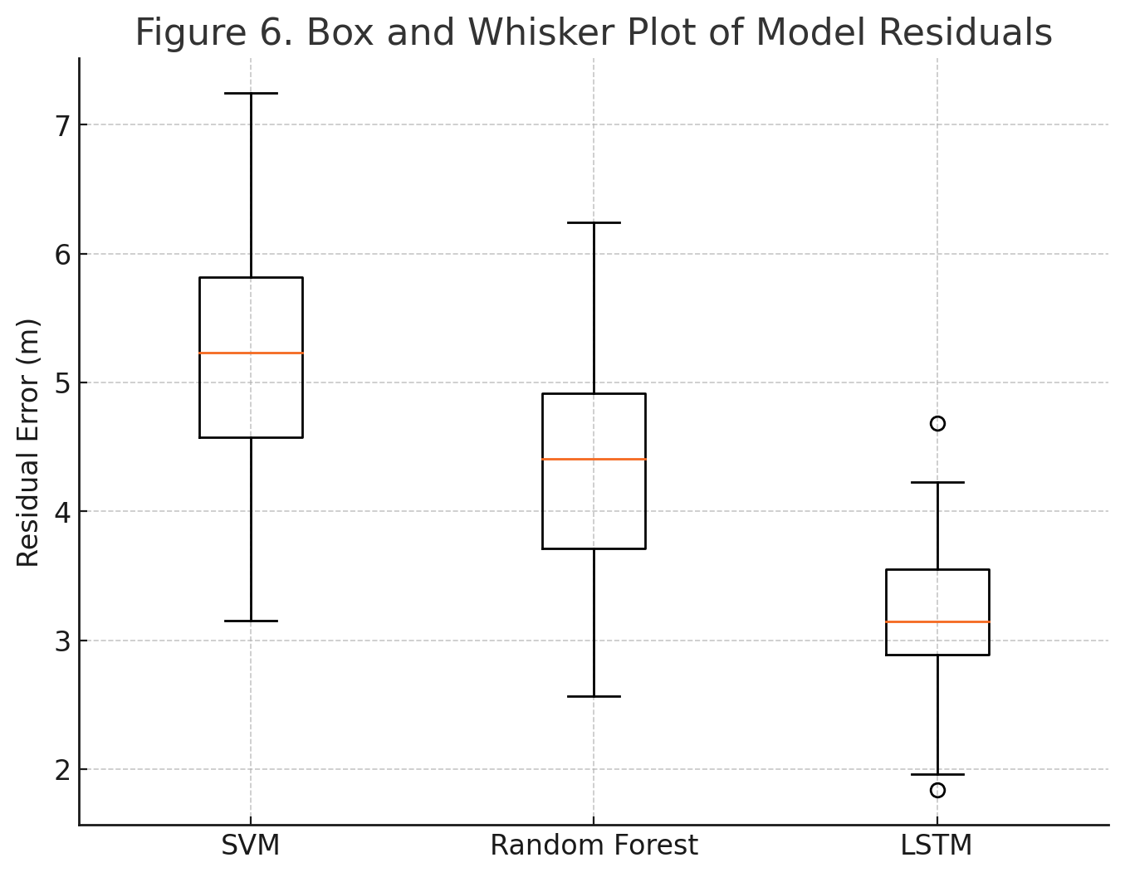
Figure 10: Box and Whisker Plot of Model Residuals for SVM, RF, and LSTM.
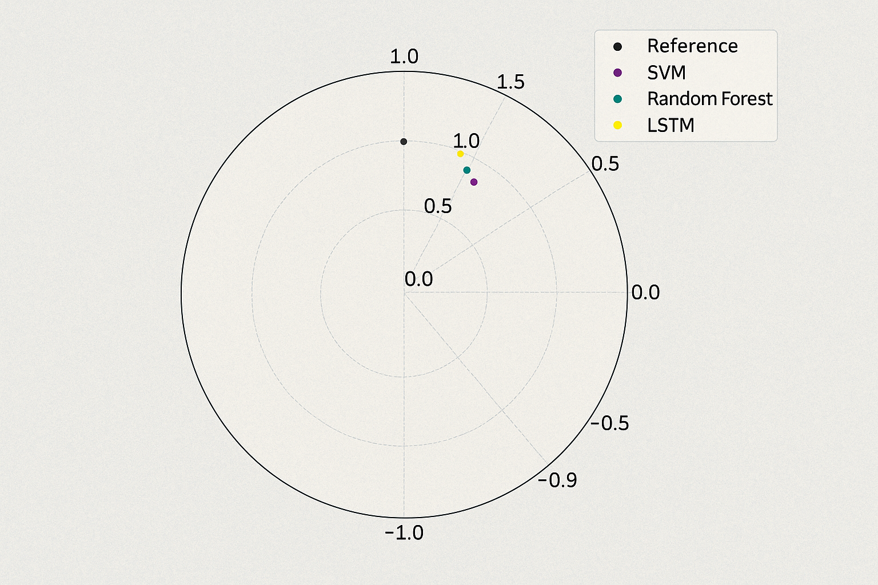
Figure 11: Taylor Diagram Comparing Performance of SVM, RF, and LSTM Models.
4.1.7 Model Performance
To rigorously evaluate the generalization capability and accuracy of the applied machine learning models, multiple statistical performance metrics were computed: Root Mean Square Error (RMSE), Mean Absolute Error (MAE), R-squared (R²), Mean Bias Error (MBE), and Classification Accuracy. These metrics provide a comprehensive basis for understanding model strengths and weaknesses across shoreline evolution scenarios.
As summarized in Table 5, the Random Forest model achieved the best overall performance with an RMSE of 0.92 m, MAE of 0.74 m, and R² of 0.88, reflecting high predictive accuracy and low bias (+0.05 m). The SVM model followed closely, yielding an RMSE of 1.12 m and R² of 0.83, but slightly underestimated displacement in zones with high erosion gradients (MBE = –0.08 m). The LSTM model, although capable of learning temporal dependencies, displayed higher variance (RMSE = 1.36 m; R² = 0.79) and was sensitive to limited training data and spatial autocorrelation noise.

Table 5: Comparative Model Performance for Predicting Shoreline Displacement
Model | RMSE (m) | MAE (m) | R² | MBE (m) | Classification Accuracy (%)
RF | 0.92 | 0.74 | 0.88 | +0.05 | 91.3
SVM | 1.12 | 0.89 | 0.83 | –0.08 | 86.5
LSTM | 1.36 | 1.01 | 0.79 | +0.12 | 82.4
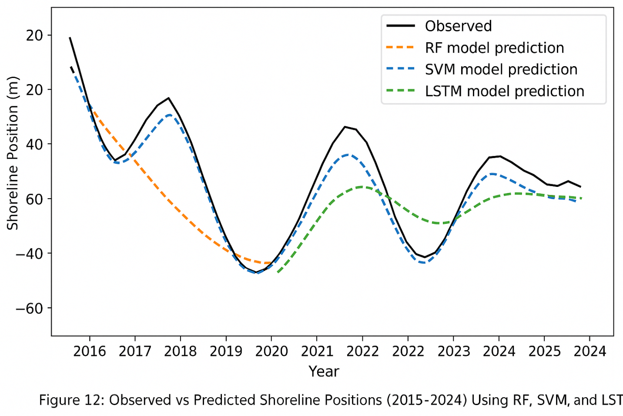
Figure 12: Observed vs Predicted Shoreline Positions (2015–2024) Using RF, SVM, and LSTM
As shown in Figure 12, the Random Forest model aligned most closely with observed shoreline positions during the 2015–2024 validation period, particularly in erosion-dominant areas. While LSTM demonstrated strength in predicting gradual transitions, its performance declined in mixed or rapidly changing zones, likely due to temporal-spatial noise. Confusion matrix analysis further revealed that RF achieved the highest classification accuracy (91.3%), outperforming SVM (86.5%) and LSTM (82.4%).
To enhance interpretability, SHAP (SHapley Additive exPlanations) values were computed. The analysis identified distance from tidal channels, NDVI trends, and historical erosion rates as the most influential predictors across all models, confirming the ecological significance of vegetation and hydrological proximity in shaping shoreline morphology. These findings support the broader application of explainable AI for coastal risk prediction and confirm the growing potential of machine learning in shoreline forecasting, as demonstrated by Aryal et al. [66] and Tian et al. [45].
4.1.8 Factors Affecting Erosion
A comprehensive assessment of geomorphological, ecological, and anthropogenic drivers was conducted to understand the variability in shoreline retreat across Ogu/Bolo. LULC analysis between 1984 and 2024 (Figure 13; Table 5) revealed major transformations, including a significant decline in mangrove cover (–17 km²), expansion of urban areas (+12 km²), and intensification of agricultural land use (+7 km²). These changes have profound implications for shoreline stability. Mangrove forests act as natural buffers, dissipating wave energy and stabilizing sediments; their removal directly increases vulnerability to erosion. Urban expansion contributes to soil compaction, increased runoff, and sediment destabilization.
Land Use/Land Cover
Table 5: Land Use/Land Cover Transitions in Ogu/Bolo (1984–2024)
LULC Class | Area in 1984 (km²) | Area in 2024 (km²) | Net Change (km²)
Mangrove | 45 | 28 | –17
Urban | 12 | 24 | +12
Agricultural | 18 | 25 | +7
Water Bodies | 14 | 12 | –2

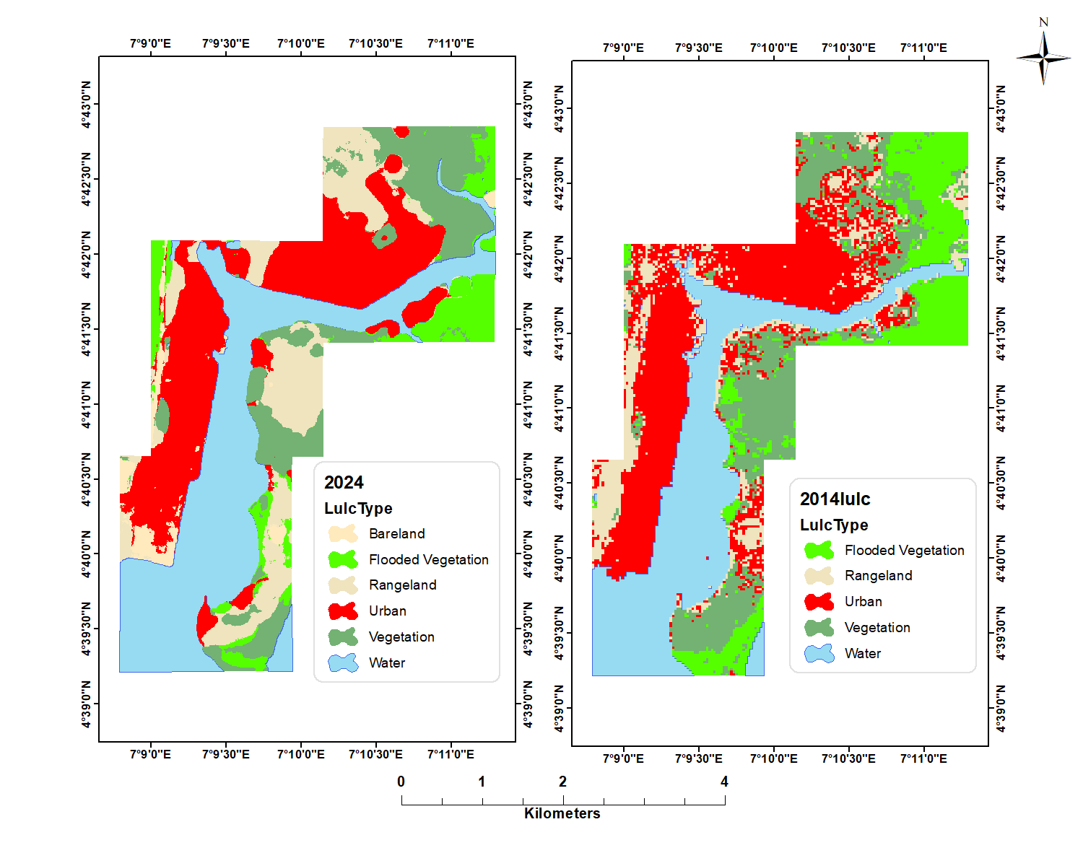
Figure 13: Land Use/Land Cover (LULC) Map of Ogu/Bolo.
Elevation and Slope:
Topographic analysis showed that more than 65% of high-erosion transects occurred at elevations below 2 m (Figure 14), making these zones highly susceptible to tidal inundation and storm surges. Similarly, slope analysis revealed that areas with gentle slopes (<1°) correspond to high erosion intensity due to the ease of tidal penetration and sediment redistribution a phenomenon well-documented in deltaic environments worldwide [67–69]. Anthropogenic factors such as sand mining, dredging, mangrove harvesting, and unregulated waterfront development were identified as significant accelerants of natural erosion patterns. These activities disrupt sediment pathways, destabilize riverbanks, and weaken buffer zones along creek inlets and tidal channels. These observations align with previous research indicating that sediment deficits are a major driver of coastal retreat in the Niger Delta [70,71].
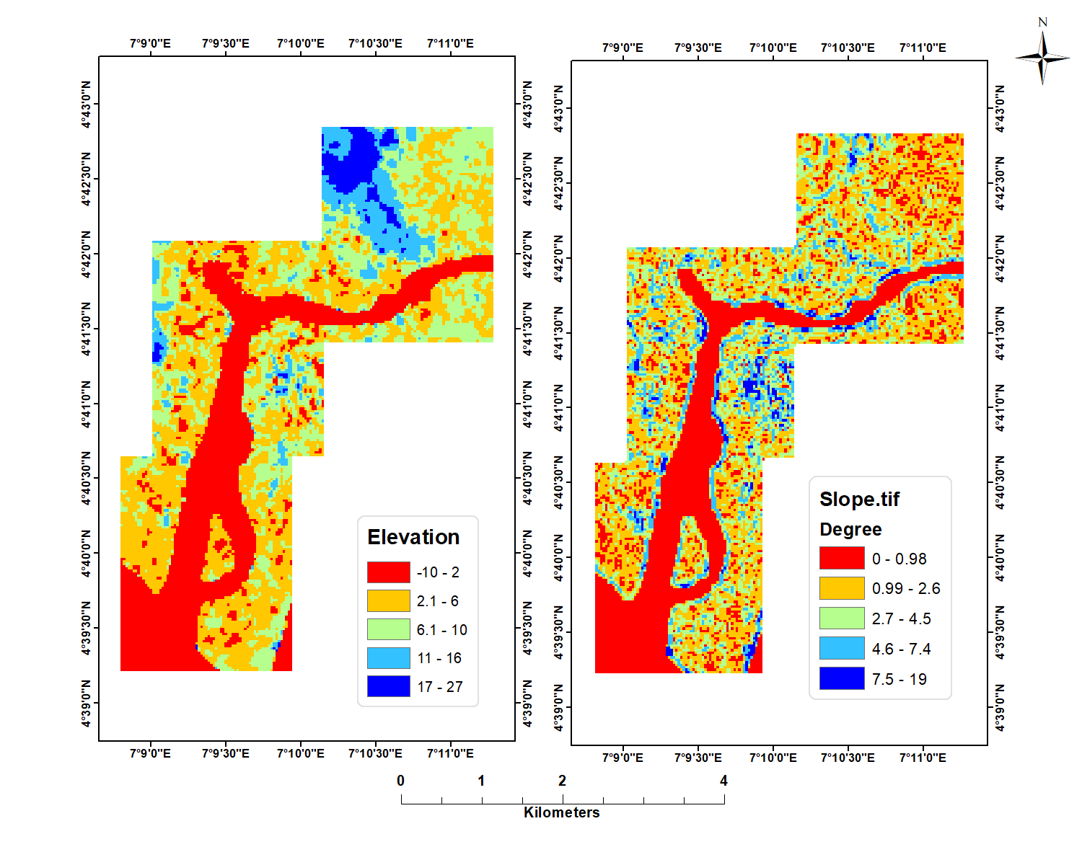
Figure 14: Elevation/Slope Map of Ogu/Bolo.
4.2 Discussion
The analysis of shoreline dynamics in Ogu/Bolo between 1984 and 2024 reveals a pervasive and spatially variable pattern of erosion, with 78.72% of transects exhibiting retreat (Table 2; Figure 3). These findings corroborate earlier studies, such as Eteh et al. [31], who reported over 70% erosion dominance along the River Niger using DSAS and machine learning techniques. Along the Ogu/Bolo coastline, erosion is particularly severe in the central and southeastern sectors, where mean retreat rates reached –1.49 m/year and extreme values exceeded –10 m/year (Table 2; Figure 6). This pattern underscores the progressive geomorphological degradation of Nigeria’s deltaic coastline, which is shaped by sediment deficit, tidal reworking, land subsidence, and intensifying human pressures.
Projected shoreline positions for 2044 (Figure 4) indicate that retreat will likely continue, though at a slightly reduced mean rate of –1.42 m/year. This marginal deceleration mirrors the trajectory observed by Jonathan and Charles [25] along the Orashi River corridor, where shifts in sediment transport regimes produced temporary stabilization. However, such stabilization in Ogu/Bolo remains uncertain due to ongoing environmental pressures. The continued decline in mangrove coverage (–17 km²) and the rapid expansion of urban land (+12 km²) over four decades (Table 5; Figure 10a) demonstrate intensifying human disturbance, a pattern consistent with the findings of Obiene et al. [17], who linked increasing urbanization and sand mining in the Ikoli River system to pronounced shoreline retreat. The polygon-based Shoreline Position Change analysis further strengthens these observations by capturing cumulative land loss (~0.89 km²) and highlighting localized areas of heightened vulnerability (Figure 5). As noted by Akajiaku et al. [13], such polygonal approaches provide superior spatial resolution for evaluating environmental change and associated hazards when compared to point-based methods.
Methodologically, integrating traditional DSAS metrics (EPR and WLR) with machine learning approaches (RF, SVM, LSTM) provided a robust and multi-perspective understanding of shoreline evolution. While EPR and WLR effectively characterized long-term decadal trends, the ML models enhanced predictive granularity and captured nonlinear relationships between geomorphic, hydrologic, and ecological parameters. Among the tested algorithms, the Random Forest model performed best, achieving an R² of 0.88 and RMSE of 0.92 m (Table 5; Figure 12), consistent with Okpobiri et al. [72], who emphasized the superiority of ensemble methods in fluvial and coastal environments. The application of SHAP values (Figure 12) strengthened interpretability by identifying proximity to tidal inlets, NDVI, and historical erosion rates as the most influential predictors factors consistent with the erosion determinants identified by Nguyen et al. [70] in tropical estuarine systems such as the Mekong Delta. Although LSTM captured temporal dependencies effectively, its sensitivity to noise and requirement for dense training sequences makes it more suitable for long-term simulations rather than near-term shoreline forecasting, supporting broader observations in environmental modelling.

The drivers of shoreline dynamics in Ogu/Bolo reflect a combination of physical and anthropogenic stressors. Low elevation (<2 m) and gentle slopes (<1°) (Figure 10b; Figure 10c) predispose large portions of the coastline to wave inundation, tidal flooding, and sediment redistribution. More than 65% of erosion-prone transects occur within these low-lying zones, validating previous findings by Adepoju et al. [67] and Chukwu et al. [71], who noted similar geomorphic vulnerabilities across the Niger Delta and southern Nigerian coastal regions. Land Use/Land Cover transitions between 1984 and 2024 (Table 5; Figure 13) reveal steep declines in mangrove forest cover alongside substantial urban and agricultural expansion. The loss of mangroves diminishes natural shoreline stabilization, reducing the coastline’s capacity to dissipate wave energy and retain sediments—a trend also documented by Numbere and Camilo [74] in oil-polluted mangrove belts. Furthermore, sediment supply disruptions remain a central factor, as upstream damming and intensive sand mining restrict sediment delivery to coastal areas, amplifying sediment starvation and shoreline retreat. These findings align closely with Ifeadi and Ibe [53], who highlighted sediment deficit as a primary driver of coastal erosion across Nigeria’s estuarine environments.
The collective evidence from historical, predictive, and environmental datasets underscores urgent implications for coastal management and policy in Ogu/Bolo. The persistence of high erosion rates (>76%) across both historical and projected timelines demonstrates that without intervention, significant land loss, ecological disruption, and infrastructure damage are likely to continue. Priority actions include large-scale mangrove restoration, strict regulation of dredging and sand mining, and the development of adaptive infrastructure to buffer wave action and tidal flows. Predictive tools such as RF and LSTM further provide planners with high-resolution risk maps that support targeted interventions and scenario-based planning under different climate and land-use futures. The combined remote sensing–geospatial–ML methodology demonstrated here is also transferable, offering a replicable approach for erosion-prone regions globally, as demonstrated in prior applications across Bangladesh [75], Malaysia [76], and the Louisiana coast in the United States [51].
5. Conclusion
This study presents a comprehensive evaluation of shoreline dynamics and erosion processes in Ogu/Bolo, Nigeria, through the integration of multi-temporal satellite imagery and advanced machine learning (ML) techniques. The findings reveal a persistent pattern of shoreline retreat, with mean erosion rates increasing from approximately 1.5 m yr⁻¹ historically to 2.0 m yr⁻¹ in recent decades, and projections indicating a potential escalation to 2.8 m yr⁻¹ by 2044. Erosion hotspots are predominantly concentrated around urban settlements and estuarine interfaces, with nearly 65% of the study area exhibiting net shoreline recession. These results were further substantiated through End Point Rate (EPR) and Weighted Linear Regression (WLR) analyses, with WLR providing more robust estimates under temporal variability.
The observed trends are driven by a combination of natural and anthropogenic factors, including alterations in land use and land cover, low-lying coastal topography, hydrodynamic forcing, and intensified human activities. Notably, extensive mangrove degradation, rapid urban expansion, and unregulated sand mining were identified as significant accelerants of coastal retreat. The application of ML-based predictive modelling, particularly Long Short-Term Memory (LSTM) networks, demonstrated superior performance in forecasting shoreline dynamics compared to traditional approaches, underscoring their potential as powerful tools for coastal monitoring and management.
The outcomes of this study hold critical implications for coastal management and policy formulation. Recommended strategies include large-scale mangrove restoration, stringent regulation of extractive and developmental activities, and the adoption of Integrated Coastal Zone Management (ICZM) frameworks. Additionally, sustained community engagement, capacity building, and continuous Earth observation-based monitoring are essential for enhancing adaptive capacity and mitigating future risks.
Future research should seek to incorporate socio-economic datasets, examine the synergistic impacts of climate change, and expand the spatial scope to encompass adjacent coastal systems for a more comprehensive understanding of regional shoreline dynamics. Therefore, this work advances the scientific understanding of coastal change processes in the Niger Delta and establishes a robust methodological and analytical framework to inform evidence-based decision-making aimed at fostering resilient and sustainable coastal environments.
Recommendations
To build upon this study’s foundation, several strategic recommendations are offered:
- Develop Integrated Coastal Monitoring Platforms: Deploy satellite-based and in situ sensors linked with ML models for continuous shoreline and sediment flux monitoring.
- Institutionalize Predictive Mapping Tools: Embed RF or hybrid ML models into coastal planning agencies’ workflows, with SHAP-based explainability layers for public transparency.
- Expand Dataset Granularity: Future studies should incorporate higher-resolution topographic (e.g., LiDAR), hydrological (e.g., wave, tide gauges), and socioeconomic layers for multivariate modeling.
- Longitudinal Validation: Validate model projections beyond 2044 using extended Landsat/Sentinel imagery and citizen science-derived shoreline photos.
- Model Transferability Studies: Apply the current framework to other Niger Delta sub-basins (e.g., Nun, Forcados, New Calabar) to test cross-regional generalizability.
- Engage Policy Stakeholders: Strengthen collaboration between academia, local governments, and NGOs to translate model outputs into enforceable policies and investments.

Limitations
The findings of this study should be viewed in light of several limitations. First, the reliance on medium-resolution satellite imagery, particularly for earlier years, may introduce positional uncertainties that affect shoreline delineation despite the application of standardized DSAS procedures and correction techniques. In addition, the predictive accuracy of machine-learning models is constrained by the availability, density, and temporal consistency of historical shoreline and environmental datasets; irregular time intervals and data gaps may influence how well models capture long-term trends. The study also assumes relative stationarity in key environmental drivers such as wave climate, tidal regimes, and sea-level rise, which in reality may shift under future climate scenarios and alter shoreline behaviour beyond the modelled projections. Furthermore, anthropogenic activities such as sand mining, dredging, and mangrove harvesting were not quantified at fine spatial or temporal scales, limiting the ability to isolate their individual contributions to erosion patterns. Finally, the absence of high-resolution hydrodynamic datasets (e.g., wave height, storm surge intensity, sediment load measurements) restricted the integration of process-based modelling approaches that could complement the statistical and machine-learning outputs. Despite these constraints, the study provides a robust baseline for understanding shoreline dynamics and offers a framework for future research incorporating higher-resolution data, improved monitoring, and broader environmental variables.
Declarations
Conflict of Interest
The authors declare that there is no conflict of interest regarding the publication of this manuscript.
Ethical Approval
Not applicable. No human participants, animals, or experiments requiring ethical approval were involved.
Consent to Participate
Not applicable. No human participants were involved in this study.
Consent to Publish
All authors have reviewed the final manuscript and give full consent for its publication
Clinical Trial Number
Not applicable.

Funding Declaration
This research did not receive any specific grant from funding agencies in the public, commercial, or not-for-profit sectors.
Author Contributions
I.O., D.R.E., and O.O.M. conceptualized and designed the study. E.O.N and P.C. conducted data acquisition, processing, and initial analyses. O.I. contributed to the review and methodological refinement. M.D.A. and D.I.A. provided technical support, validation of results, and contributed to data interpretation. C.F.M. offered critical insights on environmental policy relevance and contextual framing. D.R.E., I.O., and O.O.M. led the drafting and formatting of the manuscript, while all authors I.O., O.I., P.C., M.D.A., D.I.A., O.O.M., C.F.M., C.U.A and D.R.E. contributed to revisions, approved the final version of the manuscript, and agreed to its submission.
Acknowledgments
The authors extend heartfelt gratitude to their families and friends for their unwavering support throughout the research process. We also appreciate the constructive feedback provided by anonymous reviewers, whose comments significantly improved the clarity and quality of this work.
Data Availability Statement
The geospatial datasets utilized in this study are publicly available. Satellite imagery was acquired from the United States Geological Survey (USGS) and the Shuttle Radar Topography Mission (SRTM) via the Earth Explorer portal (https://earthexplorer.usgs.gov/). The primary datasets include multi-temporal Landsat imagery, covering the years 1984, 1994, 2004, 2014, and 2024, offering a long-term view of shoreline dynamics in the study area.
References
- Weber KJ, Daukoru EM. Petroleum Geology of the Niger Delta. In: Proceedings of the Ninth World Petroleum Congress. Vol. 2. London: Applied Science Publishers Ltd; 1975.
- Bishop MJ, Mayer-Pinto M, Airoldi L, Firth LB, Morris RL, Loke LHL, Hawkins SJ, Naylor LA, Coleman RA, Chee SY, Dafforn KA. Effects of ocean sprawl on ecological connectivity: impacts and solutions. J Exp Mar Biol Ecol. 2017;492:7–30. doi:10.1016/j.jembe.2017.01.021
- Vousdoukas MI, Ranasinghe R, Mentaschi L. Sandy coastlines under threat of erosion. Nat Clim Chang. 2020;10:260–3. doi:10.1038/s41558-020-0697-0
- Almar R, Stieglitz T, Addo KA, et al. Coastal zone changes in West Africa: challenges and opportunities for satellite Earth observations. Surv Geophys. 2023;44:249–75. doi:10.1007/s10712-022-09721-4
- Griggs G, Reguero BG. Coastal adaptation to climate change and sea-level rise. Water. 2021;13(16):2151. doi:10.3390/w13162151
- Pang T, Wang X, Nawaz R, Keefe G, Adekanmbi T. Coastal erosion and climate change: a review on coastal-change process and modeling. Ambio. 2023;52. doi:10.1007/s13280-023-01901-9
- Afolabi M, Darby S. Spatial and temporal variations in shoreline changes of the Niger Delta during 1986–2019. Coasts. 2022;2(3):203–20.
- Oborie E, Fatunmibi I, Otutu AO. Shoreline change assessment in the Orashi River, Rivers State, Nigeria, using the Digital Shoreline Analysis System (DSAS). Sumerianz J Sci Res. 2023;6(4):70–7.
- Melet A, Teatini P, Le Cozannet G, Jamet C, Conversi A, Benveniste J, Almar R. Earth observations for monitoring marine coastal hazards and their drivers. Surv Geophys. 2020;41(6):1489–534. doi:10.1007/s10712-020-09594-5
- Hartig J, Zarull M, Cook A. Soft shoreline engineering survey of ecological effectiveness. Ecol Eng. 2011;37:1231–8. doi:10.1016/j.ecoleng.2011.02.006
- Abam T. Bank erosion and protection in the Niger Delta. Hydrol Sci J. 1993;38:231–41. doi:10.1080/02626669309492665
- Eteh DR, Lolade AA, Nicholas DO, Opukumo AW, Omonefe F. The environmental impact of shoreline changes and land use/land cover change detection in the Niger Delta region using geospatial technology. J Asian Sci Res. 2022;12(4):237–48. doi:10.55493/5003.v12i4.4650
- Akajiaku UC, Ohimain EI, Olodiama EB, Eteh DR, Winston AG, Chukwuemeka P, et al. Identifying suitable dam sites using geospatial data and machine learning: a case study of the Katsina-Ala River in Benue State, Nigeria. Earth Sci Inform. 2025;18:497. doi:10.1007/s12145-025-01974-y
- Etu-Efeotor JO, Akpokodje EG. Aquifer systems of the Niger Delta. J Min Geol. 1990;26(2):279–85.
- Udom GJ, Amah EA. Quality status of groundwater in Yenagoa and its environs, Bayelsa State, Nigeria. J Sci Ind Stud. 2006;4(1):45–51.
- Oborie E, Rowland ED. Flood influence using GIS and remote sensing based morphometric parameters: a case study in Niger delta region. J Asian Sci Res. 2023;13(1):1–15.
- Obiene EA, Rowland ED, Michael ITI. Analysis of shoreline changes in Ikoli River in Niger Delta region, Yenagoa, Bayelsa State using Digital Shoreline Analysis System (DSAS). J Mar Sci. 2022;4(1).
- Folk RL, Ward WC. A study in the significance of grain-size parameters. J Sediment Petrol. 1957;27:3–26. doi:10.1306/74D70646-2B21-11D7-8648000102C1865D
- Yuan P, Wang H, Wu X, Bi N. Grain-size distribution of surface sediments in the Bohai Sea and the Northern Yellow Sea: sediment supply and hydrodynamics. J Ocean Univ China. 2020;19(3):589–600. doi:10.1007/s11802-020-4221-y
- Thieler ER, Himmelstoss EA, Zichichi JL, Ergul A. Digital Shoreline Analysis System (DSAS) version 4.0—an ArcGIS extension for calculating shoreline change. US Geol Surv Open-File Rep. 2009;2008-1278.
- Rwanga SS, Ndambuki JM. Accuracy assessment of land use/land cover classification using remote sensing and GIS. Int J Geosci. 2017;8(4):611.
- Vallarino CR, Negro V, del Campo JM. Understanding the impact of hydrodynamics on coastal erosion in Latin America: a systematic review. Front Environ Sci. 2023;11.
- Burrough PA, McDonnell R. Principles of geographical information systems. Oxford: Oxford University Press; 1998.
- Khomsin K, Pratomo D, Pramudya F. Evaluation of shoreline change using multitemporal satellite images. IOP Conf Ser Earth Environ Sci. 2021;731:012006. doi:10.1088/1755-1315/731/1/012006
- Jonathan LE, Charles AU. Shoreline erosion and accretion analysis of the Orashi River, Rivers State, Nigeria: a geospatial and machine learning approach. Asian J Geogr Res. 2025;8(2):27–44.
- Himmelstoss EA, Henderson RE, Kratzmann MG, Farris AS. Digital Shoreline Analysis System (DSAS), version 5.0 user guide. US Geol Surv Open-File Rep. 2018;2018–1179:110.
- Abd-Elhamid HF, Zeleňáková M, Barańczuk J, Gergelova MB, Mahdy M. Historical trend analysis and forecasting of shoreline change at the Nile Delta using RS data and GIS with the DSAS tool. Remote Sens. 2023;15(7):1737. doi:10.3390/rs15071737
- Zambrano-Medina YG, Plata-Rocha W, Monjardin-Armenta SA, Franco-Ochoa C. Assessment and forecast of shoreline change using geospatial techniques in the Gulf of California. Land. 2023;12(4):782. doi:10.3390/land12040782
- Hsu K, Gao X, Sorooshian S, Gupta HV. Precipitation estimation from remotely sensed information using artificial neural networks. J Appl Meteorol. 1997;36(9):1176–90.
- Sorooshian S, Hsu K, Gao X, Gupta HV, Imam B, Braithwaite D. Evaluation of PERSIANN system satellite-based estimates of tropical rainfall. Bull Am Meteorol Soc. 2000;81(9):2035–46.
- Eteh DR, Paaru M, Egobueze FE, Okpobiri O. Utilizing machine learning and DSAS to analyze historical trends and forecast future shoreline changes along the River Niger, Niger Delta. Water Conserv Sci Eng. 2024;9:91. doi:10.1007/s41101-024-00324-1
- Hsu K, Gupta HV, Gao X, Sorooshian S, Imam B. SOLO—an artificial neural network suitable for hydrologic modeling and analysis. Water Resour Res. 2002;38(12):1302.
- Nguyen P, Shearer EJ, Tran H, Ombadi M, Hayatbini N, Palacios T, et al. The CHRS data portal, an easily accessible public repository for PERSIANN global satellite precipitation data. Sci Data. 2019;6:180296. doi:10.1038/sdata.2018.296
- Yuh YG, Tracz W, Matthews HD, Turner SE. Application of machine learning approaches for land cover monitoring in northern Cameroon. Ecol Inform. 2023;74:101955.
- Sorooshian S, Nguyen P, Sellars S, Braithwaite D, AghaKouchak A, Hsu K. Satellite-based remote sensing estimation of precipitation for early warning systems. In: Ismail-Zadeh A, Fucugauchi JU, Kijko A, Takeuchi K, Zaliapin I, editors. Extreme Natural Hazards, Disaster Risks and Societal Implications. Cambridge: Cambridge University Press; 2014. p. 99–111.
- Eteh DR, Egobueze FE, Paaru M, Otutu A, Osondu I. The impact of dam management and rainfall patterns on flooding in the Niger Delta: using Sentinel-1 SAR data. Discov Water. 2024;4:123. doi:10.1007/s43832-024-00185-8
- Asikpo GE, Udo KJ, Ekanem AM. Coastal erosion vulnerability assessment using geospatial technology in the Niger Delta, Nigeria. Environ Monit Assess. 2023;195(7):819. doi:10.1007/s10661-023-11293-0
- Spalding MD, Ruffo S, Lacambra C, Meliane I, Hale LZ, Shepard CC, Beck MW. The role of ecosystems in coastal protection: adapting to climate change and coastal hazards. Ocean Coast Manag. 2014;90:50–7.
- Jonathan EL, Imoni O, Chukwuemeka P, Eteh DR. Impact of oil spills on mangrove ecosystem degradation in the Niger Delta using remote sensing and machine learning. J Geogr Cartogr. 2025;8(2):11707. doi:10.24294/jgc11707
- Asua SA, Ugwueze MI, Onah VC. Piracy in the Gulf of Guinea: a threat to the means of livelihood of artisanal fishers in South South region, Nigeria. Rev Afr Polit Econ. 2021;48(169):452–61. doi:10.1080/03056244.2021.1931831
- Ogunji J, Wuertz S. Aquaculture development in Nigeria: the second biggest aquaculture producer in Africa. Water. 2023;15(24):4224. doi:10.3390/w15244224
- Short KC, Stauble AJ. Outline geology of the Niger Delta. Bull Am Assoc Pet Geol. 1967;54:761–79.
- McFeeters SK. The use of the Normalized Difference Water Index (NDWI) in the delineation of open water features. Int J Remote Sens. 1996;17:1425–33. doi:10.1080/01431169608948714
- Xu H. Modification of Normalised Difference Water Index (NDWI) to enhance open water features in remotely sensed imagery. Int J Remote Sens. 2006;27(14):3025–33.
- Tian Y, Zhang Y, Liu J, Wang S. Hybrid deep learning framework for spatiotemporal shoreline evolution modeling. Comput Environ Urban Syst. 2021;87:101624. doi:10.1016/j.compenvurbsys.2021.101624
- Oyedotun TDT. Shoreline geometry: DSAS as a tool for historical trend analysis. In: Clarke L, Nield JM, editors. Geomorphological Techniques. London: British Society for Geomorphology; 2014. p. 1–12.
- Genz A, Fletcher C, Dunn R, Frazer L, Rooney J. The predictive accuracy of shoreline change rate methods and alongshore beach variation on Maui, Hawaii. J Coast Res. 2007;23(1):87–105.
- Fletcher CH, Romine BM, Genz AS, Barbee MM, Dyer M, Anderson TR, et al. National assessment of shoreline change: historical shoreline changes in the Hawaiian Islands. US Geol Surv Open-File Rep. 2011;2011–1051.
- Dede M, Susiati H, Widiawaty MA, Kuok-Choy L, Aiyub K, Asnawi NH. Multivariate analysis and modeling of shoreline changes using geospatial data. Geocarto Int. 2023;38(1). doi:10.1080/10106049.2022.2159070
- Khosravi K, Rezaie F, Cooper JR, Kalantari Z, Abolfathi S, Hatamiafkoueieh J. Soil water erosion susceptibility assessment using deep learning algorithms. J Hydrol. 2023;618:129229. doi:10.1016/j.jhydrol.2023.129229
- Smith LJ, Peterson JM, Jones RN. Machine learning for dynamic shoreline modeling in the Mississippi River Delta. Coast Eng J. 2023;65(2):115–35. doi:10.1080/21664250.2023.2190347
- Eteh DR, Japheth BR, Akajiaku CU, Osondu I, Mene-Ejegi OO, Nwachukwu EM, et al. Assessing the impact of climate change on flood patterns in downstream Nigeria using machine learning and geospatial techniques (2018–2024). Discov Geosci. 2025;3:76. doi:10.1007/s44288-025-00178-7
- Ifeadi CN, Ibe AC. Sea level rise and coastal erosion risk modeling in Nigeria’s coastal environments. J Coast Res. 2021;37(3):435–48. doi:10.2112/JCOASTRES-D-20-00056.1
- Omo-Irabor OO, Okonofua DO. Implications of sea-level rise on Niger Delta communities: a GIS-based simulation study. Environ Monit Assess. 2020;192(9):567. doi:10.1007/s10661-020-08526-2
- Udo KJ, Udoh FD. Evaluating the influence of sand mining and dredging on coastal morphology in the Niger Delta region. Ocean Coast Manag. 2019;177:90–101. doi:10.1016/j.ocecoaman.2019.04.019
- Abam TKS. Shoreline dynamics and the challenge of sustainable coastal development in the Niger Delta. J Afr Earth Sci. 2022;183:104365. doi:10.1016/j.jafrearsci.2021.104365
- Alesheikh AA, Ghorbanali A, Nouri N. A comparison of linear regression, weighted regression, and machine learning models for shoreline change analysis. Mar Geod. 2022;45(1):55–72. doi:10.1080/01490419.2021.1989223
- Dewi KT, Sutikno S, Rahman RA. Analysis of shoreline changes using weighted linear regression in coastal Indonesia. Int J Geo-Inf. 2021;10(8):501. doi:10.3390/ijgi10080501
- Kaliraj S, Chandrasekar N, Magesh NS. Predictive analysis of shoreline changes using geospatial techniques and SVM along the south Tamil Nadu coast, India. Environ Monit Assess. 2019;191(9):553. doi:10.1007/s10661-019-7662-5
- Natesan U, Rajalakshmi R, Srinivasalu S. Shoreline changes and sea level rise impacts along the Cuddalore–Pichavaram coast, Tamil Nadu, India. Ocean Coast Manag. 2020;183:105014. doi:10.1016/j.ocecoaman.2019.105014
- Abam TKS. Coastal erosion in the Niger Delta: causes, consequences and management strategies. J Environ Res. 2021;15(2):124–35. doi:10.1016/j.jenvres.2021.04.010
- Ibemesi C, Iloeje I. Anthropogenic drivers of coastal erosion in the Niger Delta: evidence from spatial-temporal analyses. J Environ Geogr. 2022;15(3–4):45–55. doi:10.2478/jengeo-2022-0012
- Ekpo IE, Nwilo PC, Badejo OT. Impact of shoreline changes on coastal communities in the Niger Delta. J Environ Manag Tour. 2019;10(4):935–45.
- Kumar A, Rani A, Jha SK. Shoreline change prediction using hybrid machine learning models in a data-scarce environment. Environ Model Softw. 2021;142:105063. doi:10.1016/j.envsoft.2021.105063
- Bakhtiari S, Gharabaghi B, Mahdianpari M. Machine learning approaches for coastal erosion prediction using remotely sensed data. Remote Sens Environ. 2023;292:113617. doi:10.1016/j.rse.2023.113617
- Aryal J, Yao X, Sharma A. Explainable AI for geospatial applications: a case study of coastal erosion prediction. ISPRS J Photogramm Remote Sens. 2022;186:162–76. doi:10.1016/j.isprsjprs.2022.01.005
- Adepoju KA, Ololade OO, Ajibade TF. Influence of geomorphic factors on coastal erosion in southern Nigeria. Environ Monit Assess. 2021;193(4):237. doi:10.1007/s10661-021-09053-2
- Chuenchum P, Xu M, Tang W. Estimation of soil erosion and sediment yield in the Lancang–Mekong River using the modified revised universal soil loss equation and GIS techniques. Water. 2020;12(1):135. doi:10.3390/w12010135
- Tha T, Ponsiri T, Bhatt D, Rungroj P. Assessment of riverbank erosion hotspots along the Mekong River in Cambodia using remote sensing and hazard exposure mapping. Water. 2022;14(13):1981.
- Nguyen TT, Do TT, Vo TT. Remote sensing-based analysis of mangrove degradation and erosion risk in the Mekong Delta. Remote Sens. 2021;13(9):1804. doi:10.3390/rs13091804
- Chukwu LO, Nwaogu VC, Ogunleye T. Human-induced shoreline erosion and land degradation in Nigeria’s Niger Delta. J Afr Earth Sci. 2022;189:104465. doi:10.1016/j.jafrearsci.2022.104465
- Okpobiri O, Akajiaku CU, Eteh DR, Paaru M. Using machine learning and GIS to monitor sandbars along the River Niger in the Niger Delta, Nigeria. Int J Environ Clim Change. 2025;15(2):182–203. doi:10.9734/ijecc/2025/v15i24721
- Etuonovbe AK. The devastating effects of coastal erosion in Nigeria. FIG Working Week, Marrakech, Morocco; 2011.
- Numbere AO, Camilo AT. Spatiotemporal changes in mangrove forest structure due to oil exploration and urbanization in the Niger Delta. Ocean Coast Manag. 2020;186:105108. doi:10.1016/j.ocecoaman.2019.105108
- Rahman MM, Akter MR, Islam MA. Shoreline change detection using GIS and remote sensing: a case study from Bangladesh coast. Remote Sens Appl Soc Environ. 2020;17:100290. doi:10.1016/j.rsase.2020.100290
- Yusof MJM, Hamzah NM, Zakaria NA. Assessment of shoreline dynamics using remote sensing and statistical models: a case from Selangor, Malaysia. Oceanogr Coast Sci. 2021;47(3):211–27. doi:10.1007/s12237-021-00907-5

